TASK 12

Loan Database Management System

Aim: To prepare Loan Database management system.

STEP 1:Implementation of ER Model and Schema

Steps involved in er model:

- Identify Entities Identify the main objects or entities that will be represented in the diagram. Entities typically represent real-world objects, people, or concepts (e.g., Employee, Customer, Product).

- Determine Attributes For each entity, determine the attributes or properties that describe the entity (e.g., Employee attributes could be EmployeeID, Name, and Department).

- Identify Relationships Identify how the entities are related to one another (e.g., Employee works for Department). Relationships describe the associations between entities.

- Determine Cardinality Define the cardinality of each relationship (i.e., one-to-one, one-to- many, or many-to-many). This shows how many instances of one entity relate to instances of another entity.

- Draw the Diagram Draw Entities: Use rectangles to represent each entity. Add Attributes: Use ovals to represent attributes and connect them to the corresponding entity. Draw Relationships: Use diamonds to represent relationships and connect the entities involved. Indicate Cardinality: Use numbers or symbols (1, N) next to the relationship lines to show cardinality.
OUTPUT:

ER MODEL FOR LOAN DATABASE MANAGEMENT SYSTEM:

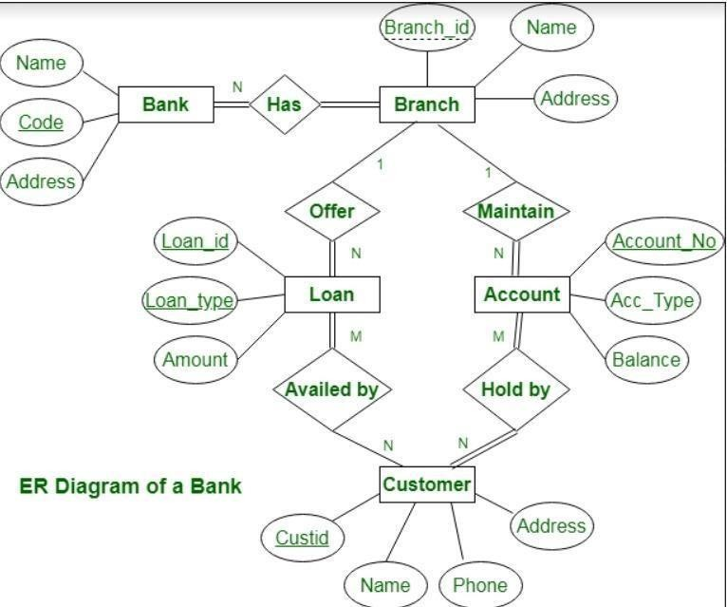

STEP 2 : Conversion of ER Model To Relation Model
Converting an Entity-Relationship (ER) Model to a Relational Model Is a Crucial Step in Designing a Relational Database. This Process Involves Translating the Entities, Attributes, and Relationships Defined in the ER Diagram Into Tables, Columns, and Keys in a Relational Schema. Below Are the Comprehensive Steps To Perform This Conversion Effectively.

Steps To Convert an ER Model to a Relational Model:
1: Mapping of Regular Entity Types2: Mapping of Weak Entity Types
3: Mapping of Binary 1:1 Relation Types
4: Mapping of Binary 1:N Relationship Types. 5: Mapping of Binary M:N Relationship Types. 6: Mapping of Multivalued Attributes.
7: Mapping of N-Ary Relationship …
ER Model Components
- Entities: Identify the main entities involved. For a loan database, you might have:
  - Customer
  - Loan
  - Payment
  - Loan Officer
- Attributes: Define attributes for each entity. For example:
  - Customer: CustomerID, Name, Address, PhoneNumber
  - Loan: LoanID, Amount, InterestRate, StartDate, CustomerID (foreign key)
  - Payment: PaymentID, Amount, PaymentDate, LoanID (foreign key)
  - Loan Officer: OfficerID, Name, Department
- Relationships: Determine how entities relate to each other.
  - A Customer can have multiple Loans (One-to-Many).
    - A Loan can have multiple Payments (One-to-Many).
    - A Loan is managed by a Loan Officer (Many-to-One).
Steps to Convert to Relational Model:
Create Tables for Entities: Each entity becomes a table. The primary key (PK) is identifiedfor each table.
Syntax For Er model: CREATE TABLE Customer (
CustomerID INT PRIMARY KEY,Name VARCHAR(255), Address VARCHAR(255),
PhoneNumber VARCHAR(15)
);

CREATE TABLE Loan ( LoanID INT PRIMARY
KEY,Amount
DECIMAL(10, 2),
InterestRate DECIMAL(5, 2),StartDate DATE, EndDate DATE, CustomerID INT,
FOREIGN KEY (CustomerID) REFERENCES Customer(CustomerID)
);
CREATE TABLE Payment ( PaymentID INT PRIMARY KEY,
PaymentDate DATE, Amount DECIMAL(10, 2),LoanID INT,
FOREIGN KEY (LoanID) REFERENCES Loan(LoanID)
);
- Define Relationships: Relationships are established through foreign keys (FK).
  - In the Loan table, CustomerID is a foreign key referencing Customer(CustomerID), indicating that each loan belongs to one customer.
  - In the Payment table, LoanID is a foreign key referencing Loan(LoanID),indicating that each payment is associated with one loan.
Summary of Relational Model:
- Customer Table:
  - Holds customer details.
- Loan Table:
  - Holds loan details and includes a reference to the customer who took theloan.
- Payment Table:
  - Holds payment details and includes a reference to the loan for which the paymentwas made.

STEP 3 : Implementation of DDL,DML,DCL,TCL, COMMANDS .

DDL COMMANDS:
CREATE :To Add a New Object to the Database. ALTER : To Change the Structure of the Database.
DROP : To Remove an Existing Object From the Database. ...
TRUNCATE : To Remove all Records From a Table, Including the Space Allocated To Store This Data.

DML_COMMANDS:
CREATE : To Add a New Object to the Database. ALTER : To Change the Structure of the Database.
DROP : To Remove an Existing Object From the Database. ...
TRUNCATE : To Remove all Records From a Table, Including the Space Allocated To Store This Data.

DCL COMMANDS :
DCL Includes Two Commands, GRANT and REVOKE

TCL COMMANDS :
Commit, Rollback, and Savepoint. TCL Commands Are Important for Maintaining ACID
Properties. These Commands Allow You To Commit or Discard Changes, Manage Savepoints, and Control theOverall Flow of Data Modifications.

DDL SYNTAX AND OUTPUT:
CREATE:
Create table loandatabase(sno number(20), branchname varchar(20),customername varchar(20), cust_id int,loan_id int);
OUTPUT:
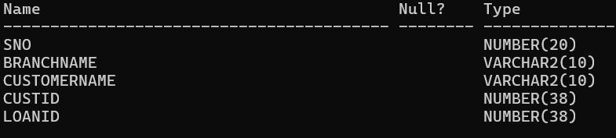
ALTER:
alter table loandatabase modify customername varch
OUTPUT:
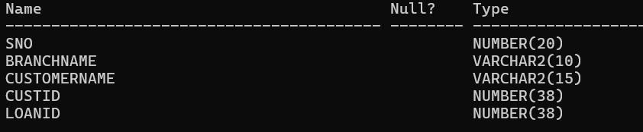
DML SYNTAX AND OUTPUT:
INSERT:
SQL> insert into loandatabase values(1,'kadapa','meena',123,234);1 row created.

SQL> insert into loandatabase values(2,'nellore','shalini',345,564);1 row created.

SQL> insert into loandatabase values(3,'guntur','bhoomi',435,657);1 row created.

SQL> insert into loandatabase values(4,'avadi','harshitha',457,567);
1 row created.

SQL> insert into loandatabase values(5,'produttur','teja',987,908);1 row created.

SQL> insert into loandatabase values (6,'annanur','siri',409,108); 1 row created.

OUTPUT:
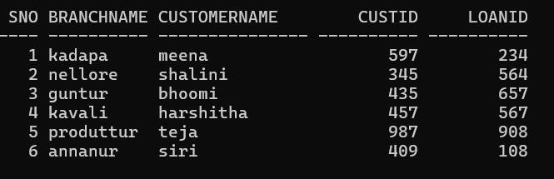
UPDATE:
SQL> update loandatabase set custid=123 where loanid=234; SQL> update loandatabase set custid=597 where loanid=234;
SQL> update loandatabase set branchname='kavali' where custid=457;
OUTPUT:
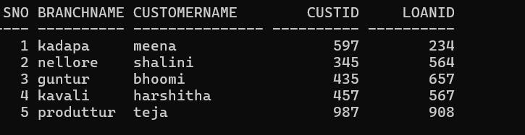

DELETE:
SQL> delete from loandatabase where customername='siri';

OUTPUT:
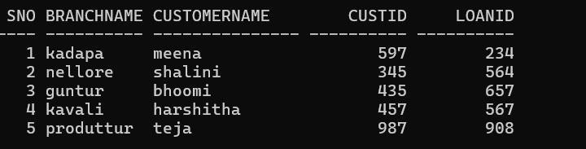
SELECT:
SQL> select branchname from loandatabase;
OUTPUT:
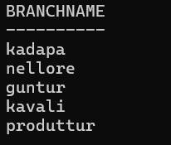
SQL> select distinct custid from loandatabase;
OUTPUT:
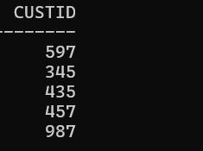

SQL> select*from loandatabase where loanid between 657 and 908;
OUTPUT:
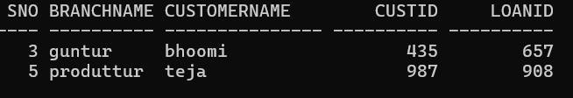
TCL SYNTAX AND OUTPUT:
SQL> commit; Commit complete.

SQL> savepoint k1;
Savepoint created.
SQL> rollback to k1;Rollback complete.

Step 4:Aggregate Functions
- SUM: Calculate total loan amount SELECT SUM(LoanAmount) AS TotalLoanAmountFROM Loan;
- AVG: Calculate average borrower age
SELECT AVG(DATEDIFF(CURRENT_DATE, DateOfBirth) / 365.25) AS AvgAge
FROM Borrower;
- MAX: Find the largest loan amount SELECT MAX(LoanAmount) AS LargestLoanAmountFROM Loan;
- MIN: Find the smallest loan amount SELECT MIN(LoanAmount) AS SmallestLoanAmountFROM Loan;
- COUNT: Count number of borrowers SELECT COUNT(BorrowerID) AS
NumBorrowersFROM Borrower; Join Operations
- INNER JOIN: Join borrowers with loans SELECT B.FirstName, B.LastName, L.LoanAmountFROM Borrower B
INNER JOIN Loan L ON B.BorrowerID = L.BorrowerID;
- LEFT JOIN: Join borrowers with loans (include borrowers without loans)SELECT B.FirstName, B.LastName, L.LoanAmount
FROM Borrower B
LEFT JOIN Loan L ON B.BorrowerID = L.BorrowerID;
- RIGHT JOIN: Join borrowers with loans (include loans without borrowers)SELECT B.FirstName, B.LastName, L.LoanAmount
FROM Borrower B
RIGHT JOIN Loan L ON B.BorrowerID = L.BorrowerID;
- FULL OUTER JOIN: Join borrowers with loans (include borrowers and loans without matches)SELECT B.FirstName, B.LastName, L.LoanAmount
FROM Borrower B
FULL OUTER JOIN Loan L ON B.BorrowerID = L.BorrowerID;

Step 5:Nested Queries (Subqueries):
Nested queries, or subqueries, are useful when you need to use the result of one query as input toanother query.
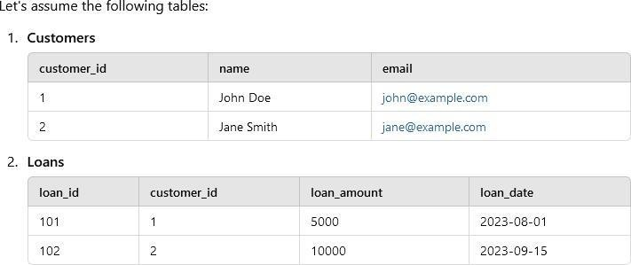
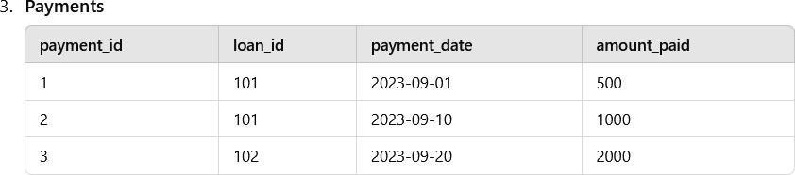

SELECT name, email FROM Customers WHERE customer_id IN (
SELECT customer_id FROM Loans WHERE loan_id IN (
SELECT loan_id FROM Payments GROUP BY loan_id
HAVING SUM(amount_paid) > 1000
)
);
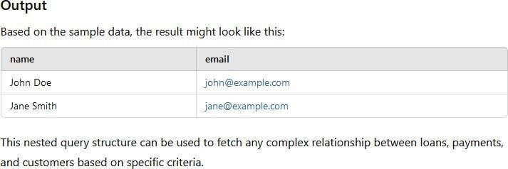

JOIN Query

SELECT
c.name, c.email, l.loan_amount, l.loan_date,
SUM(p.amount_paid) AS total_payments FROM Customers c
JOIN Loans l ON c.customer_id = l.customer_id LEFT JOIN Payments p ON l.loan_id = p.loan_id GROUP BY c.customer_id, l.loan_id;
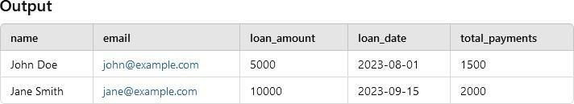

View:
CustomerLoanDetails
This view shows customer details along with loan information. CREATE VIEW CustomerLoanDetails AS
SELECT
c.customer_id, c.name, c.email, l.loan_id, l.loan_amount, l.loan_date
FROM Customers c
JOIN Loans l ON c.customer_id = l.customer_id;
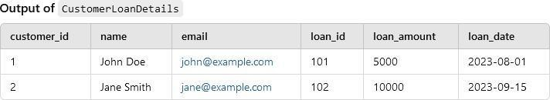

Index
on payment_date in the Payments table
If you frequently query based on the payment_date, such as when finding overdue loans or recent payments, you can create an index on this column.

CREATE INDEX idx_payments_payment_date ON Payments (payment_date);
This index will speed up queries like:
SELECT *
FROM Payments
WHERE payment_date > '2023-09-01';
Output
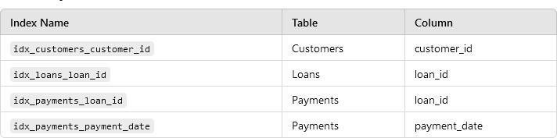

Limit
Get the First 2 Customers
you want to retrieve only the first 2 customers from the Customers table:

SELECT * FROM Customers LIMIT 2;
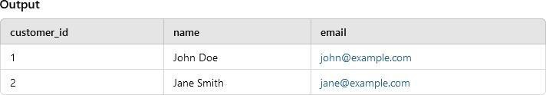

Retrieve the Latest 2 Loan Records
To retrieve the most recent 2 loans based on the loan_date, you can order the loans by date in descending order and apply the LIMIT clause.

SELECT *
FROM Loans
ORDER BY loan_date DESC LIMIT 2;
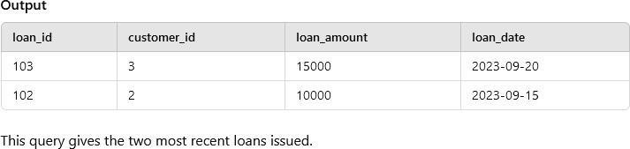

STEP 6: NORMALIZATION(Grefith Tool)
Assume we have a table with the following attributes related to loans:
- LoanID
- BorrowerName
- BorrowerPhoneNumbers
- LoanAmount
- LoanDate
- RepaymentSchedule Issues with the Initial Table
Initially, our table might look like this:

LoanI  D | BorrowerNa  me | BorrowerPhoneNumb  ers | LoanAmou  nt | LoanDat RepaymentSched  e ule
1 | John Doe | 123-456-7890, 987-  654-3210 | $10,000 | 2023-01-  15 | Monthly
2 | Jane Smith | 555-123-4567 | $5,000 | 2023-02-  20 | Bi-Weekly
Problems
- Repeating Groups: The BorrowerPhoneNumbers attribute contains multiple values, violating the atomicity requirement of 1NF.
- Non-Atomic Values: Phone numbers are not stored as atomic values, making it difficult to query or manipulate them individually.
Converting to 1NF
To convert the table to 1NF, we need to ensure that all attributes contain atomic values. We can achieve this by creating a separate entry for each phone number.
Normalized Table in 1NF
LoanI BorrowerNa BorrowerPhoneNumb LoanAmou LoanDat RepaymentSchedu
le
D | me | er | nt
1 | John Doe | 123-456-7890 | $10,000
1 | John Doe | 987-654-3210 | $10,000
2 | Jane Smith | 555-123-4567 | $5,000

e
2023-01-
15
2023-01-
15
2023-02-
20
Summary of Changes

Monthly Monthly Bi-Weekly

- The BorrowerPhoneNumbers column was split into multiple rows for each unique phone number associated with a borrower.
- This results in redundancy for the LoanID, BorrowerName, LoanAmount, LoanDate, and RepaymentSchedule, but now all fields contain atomic values, which satisfies 1NF.
Next Steps
After achieving 1NF, you can proceed to further normalize the database to 2NF and 3NF, where you'll focus on removing partial and transitive dependencies to ensure a more efficient and structured database design. If you need guidance on those steps, feel free to ask!
Step 1: Unnormalized Table
Let's start with a simple, unnormalized table representing loans:

LoanI  D | BorrowerNa  me | BorrowerPhoneNumb  ers | LoanAmou  nt | LoanDat RepaymentSched  e ule
1 | John Doe | 123-456-7890, 987-  654-3210 | $10,000 | 2023-01-  15 | Monthly
2 | Jane Smith | 555-123-4567 | $5,000 | 2023-02-  20 | Bi-Weekly
Issues:
- Repeating Groups: Multiple phone numbers in a single field.
- Non-Atomic Values: The phone numbers are not atomic (individual).
Step 2: First Normal Form (1NF)
To convert to 1NF, we ensure that all fields contain atomic values:
LoanI BorrowerNa BorrowerPhoneNumb LoanAmou LoanDat RepaymentSchedu
e
D | me | er | nt
1 | John Doe | 123-456-7890 | $10,000
1 | John Doe | 987-654-3210 | $10,000
2 | Jane Smith | 555-123-4567 | $5,000

2023-01-
15
2023-01-
15
2023-02-
20
le

Monthly
Monthly Bi-Weekly

Step 3: Second Normal Form (2NF)
To achieve 2NF, we need to remove partial dependencies. In this table, BorrowerName, LoanAmount, LoanDate, and RepaymentSchedule depend only on LoanID, while BorrowerPhoneNumber does not depend solely on LoanID.
We can split the data into two tables:
- Loans Table
LoanID BorrowerName LoanAmount LoanDate RepaymentSchedule

1 | John Doe | $10,000 | 2023-01-15 Monthly
2 | Jane Smith | $5,000 | 2023-02-20 Bi-Weekly

- BorrowerPhoneNumbers Table LoanID BorrowerPhoneNumber
1 | 123-456-7890
1 | 987-654-3210
2 | 555-123-4567

Step 4: Third Normal Form (3NF)
To achieve 3NF, we need to remove transitive dependencies. In the Loans Table, if we had additional information like the borrower's address, it could create transitive dependencies if that data was also linked to BorrowerName.
For simplicity, assume we want to further normalize by adding a Borrowers table:
- Loans Table (remains unchanged):
LoanID BorrowerID LoanAmount LoanDate RepaymentSchedule
1 1 $10,000 2023-01-15 Monthly
LoanID BorrowerID LoanAmount LoanDate RepaymentSchedule
2 2 $5,000 2023-02-20 Bi-Weekly

- Borrowers Table
BorrowerID BorrowerName Address

1 | John Doe | 123 Elm St
2 | Jane Smith | 456 Oak Ave

- BorrowerPhoneNumbers Table (remains unchanged):
LoanID BorrowerPhoneNumber

1 | 123-456-7890
1 | 987-654-3210
2 | 555-123-4567

Summary
By following these steps, we’ve successfully normalized our loan database through:
  - 1NF: Ensured atomicity of fields.
  - 2NF: Eliminated partial dependencies.
  - 3NF: Removed transitive dependencies.

STEP 7: Applying the advanced data base for the traditional model
Database structure
- Borrowers Collection
{
"_id": ObjectId("..."),
"name": "John Doe",
"email": "johndoe@example.com", "phone": "123-456-7890",
"address": {
"street": "123 Elm St",
"city": "Springfield", "state": "IL",
"zip": "62701"
},
"date_joined": ISODate("2024-01-15"), "credit_score": 720
}
- Loans Collection
{
"_id": ObjectId("..."),
"borrower_id": ObjectId("..."), // Reference to Borrower "amount": 15000,
"interest_rate": 5.0,
"term_months": 36, "status": "active",
"start_date": ISODate("2024-01-15"), "collateral": [
{
"type": "car", "value": 20000
}
]
}
- Payments Collection
{
"_id": ObjectId("..."),
"loan_id": ObjectId("..."), // Reference to Loan "amount": 500,
"payment_date": ISODate("2024-02-01"),
"status": "completed"
}
- Lenders Collection
{
"_id": ObjectId("..."), "name": "XYZ Finance Co.","contact_info": {
"email": "contact@xyzfinance.com", "phone": "987-654-3210"
}
}
- CRUD Operations
Here’s how you can perform CRUD operations on this loan management system.
Create OperationsInsert a Borrower:
db.Borrowers.insertOne({ nam e: "John Doe",
email: "johndoe@example.com", phone: "123-456-7890",
address: {
street: "123 Elm St", city: "Springfield", state: "IL",
zip: "62701"
},
date_joined: new Date("2024-01-15"), credit_score: 720
})
;
Insert a Loan:
const borrowerId = ObjectId("..."); // Replace with the actual ObjectId of John Doe db.Loans.insertOne({
borrower_id: borrowerId, amount: 15000,
interest_rate: 5.0,
term_months: 36, status: "active",
start_date: new Date("2024-01-15"), collateral: [
{

]
});
type: "car", value: 20000
}
Insert a Payment:
const loanId = ObjectId("..."); // Replace with the actual ObjectId of the loan db.Payments.insertOne({
loan_id: loanId, amount: 500,
payment_date: new Date("2024-02-01"), status: "completed"
});
Read Operations
Find a Borrower by Email:
const borrower = db.Borrowers.findOne({ email: "johndoe@example.com" });
Get All Loans for a Borrower:
const loans = db.Loans.find({ borrower_id: borrowerId }).toArray();
Get Payment History for a Loan:
const payments = db.Payments.find({ loan_id: loanId }).toArray();
Update Operations
Update Borrower Information:
db.Borrowers.updateOne(
{ _id: borrowerId },
{ $set: { phone: "987-654-3210", credit_score: 740 } }
);
Update Loan Status:
db.Loans.updateOne(
{ _id: loanId },
{ $set: { status: "closed" } }
);
Delete OperationsDelete a Payment:
db.Payments.deleteOne({ _id: ObjectId("...") }); // Replace with actual ObjectId
Delete a Loan:
db.Loans.deleteOne({ _id: loanId });
Delete a Borrower:
db.Borrowers.deleteOne({ _id: borrowerId });
- Sample Outputs
Here are some example outputs you might expect after running the CRUD operations.
- Output of Find Borrower by Email:
{
"_id": ObjectId("..."),
"name": "John Doe",
"email": "johndoe@example.com", "phone": "123-456-7890",
"address": {
"street": "123 Elm St",
"city": "Springfield", "state": "IL",
"zip": "62701"
},
"date_joined": ISODate("2024-01-15"), "credit_score": 720
}
- Output of All Loans for a Borrower:
[
{
"_id": ObjectId("..."),
"borrower_id": ObjectId("..."), "amount": 15000,
"interest_rate": 5.0,
"term_months": 36, "status": "active",
"start_date": ISODate("2024-01-15"), "collateral": [
{
"type": "car", "value": 20000
}
]
}
]
- Output of Payment History for a Loan:
[
{
"_id": ObjectId("..."),
"loan_id": ObjectId("..."),"amount":
500,
"payment_date": ISODate("2024-02-01"), "status": "completed"
}
]

Result :
Thus the given use case has been implemented using ER model, sql commands ,nested queries,aggregate function ,and finally normalization is done .convertion of traditional database to Advance Database done using mongoldb database.Thus implementation of loan database management system is implemented successfully with given constraints.

